**Output:**

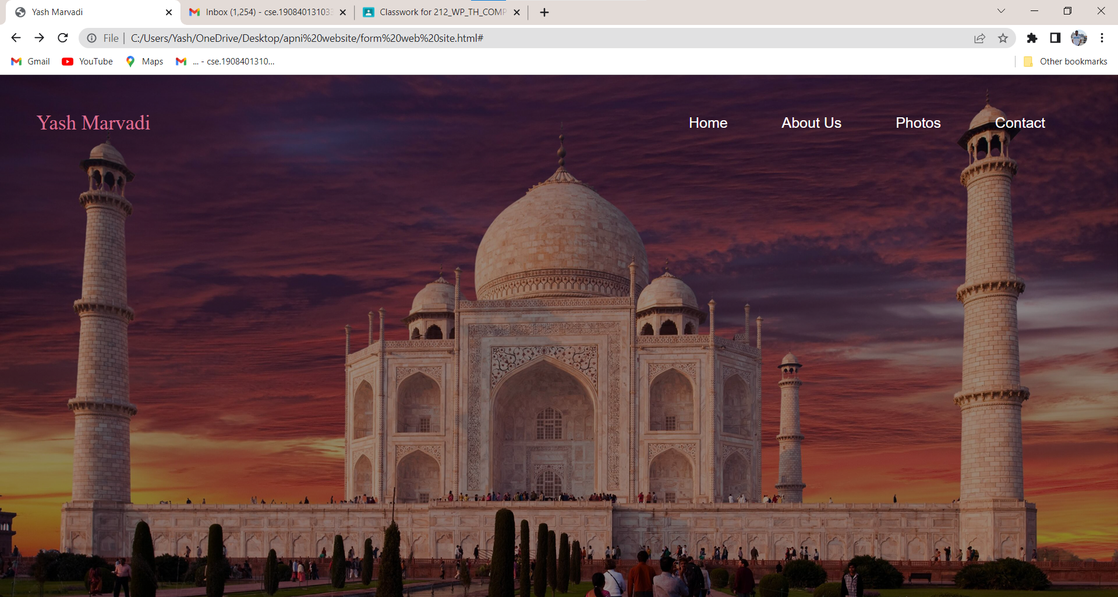

**After click in Yash Marvadi name button in navigation bar:**

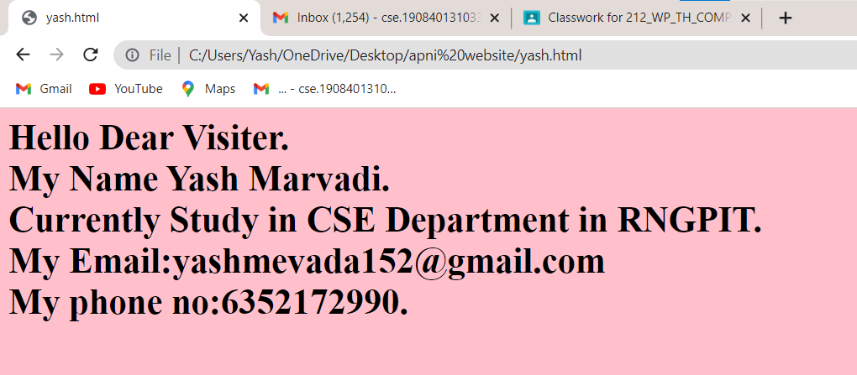

**After click on About us button in navigation bar:**

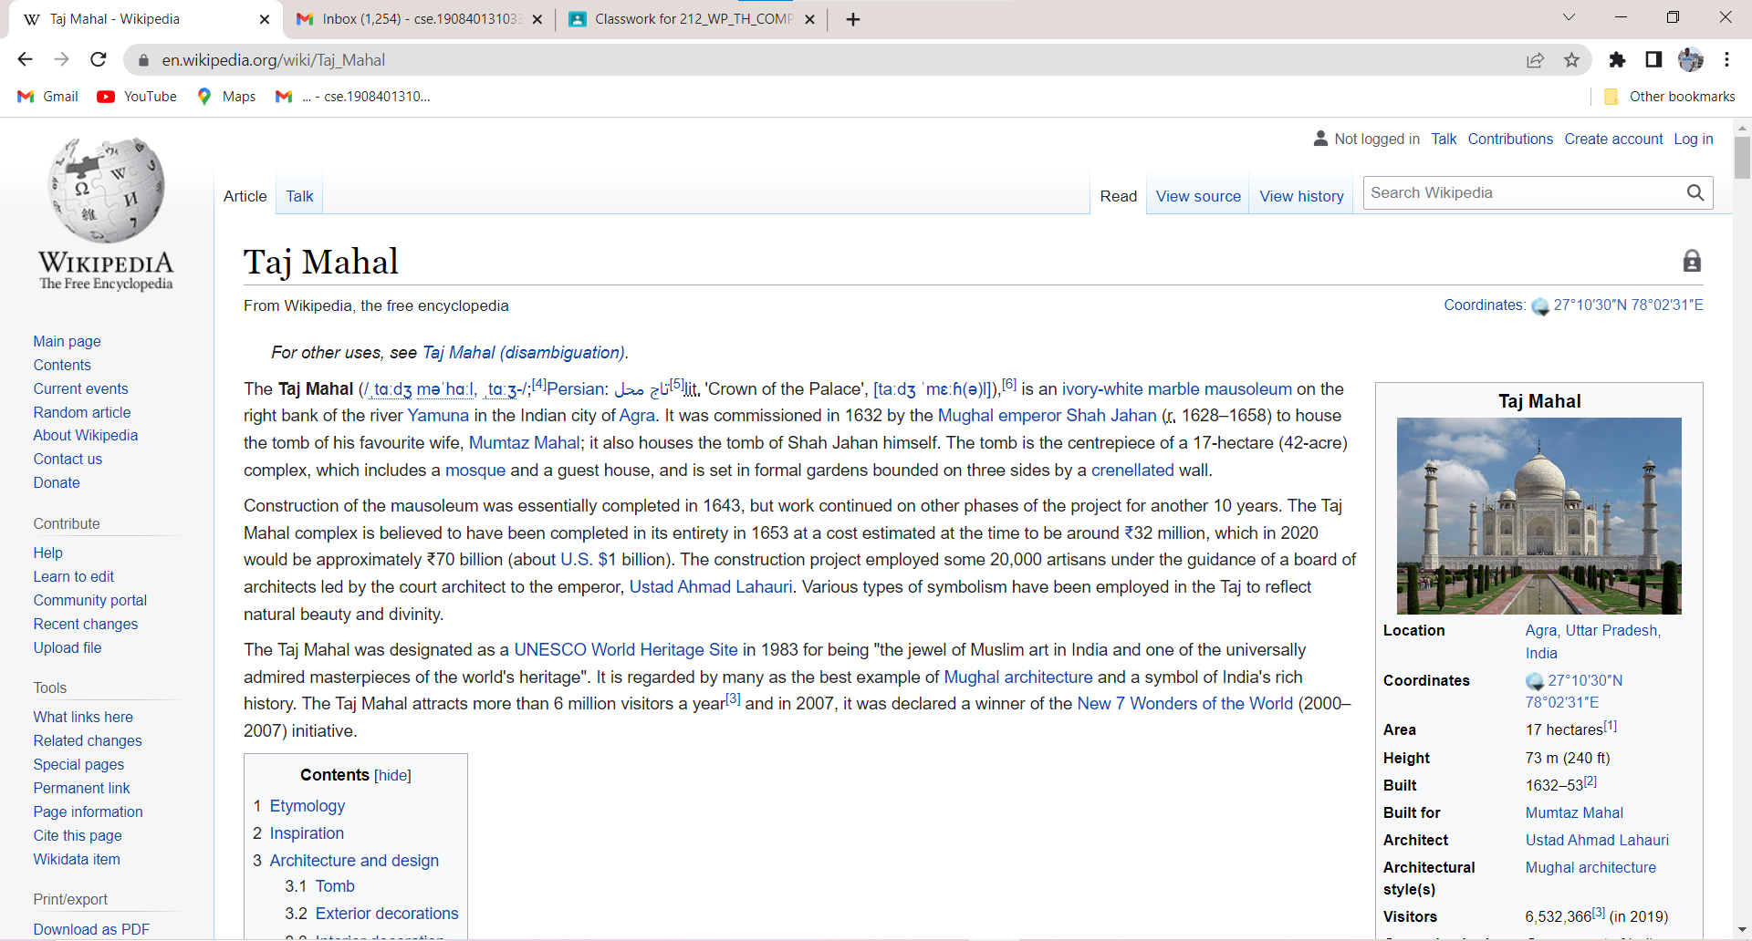

**After click on Image button in navigation bar:**

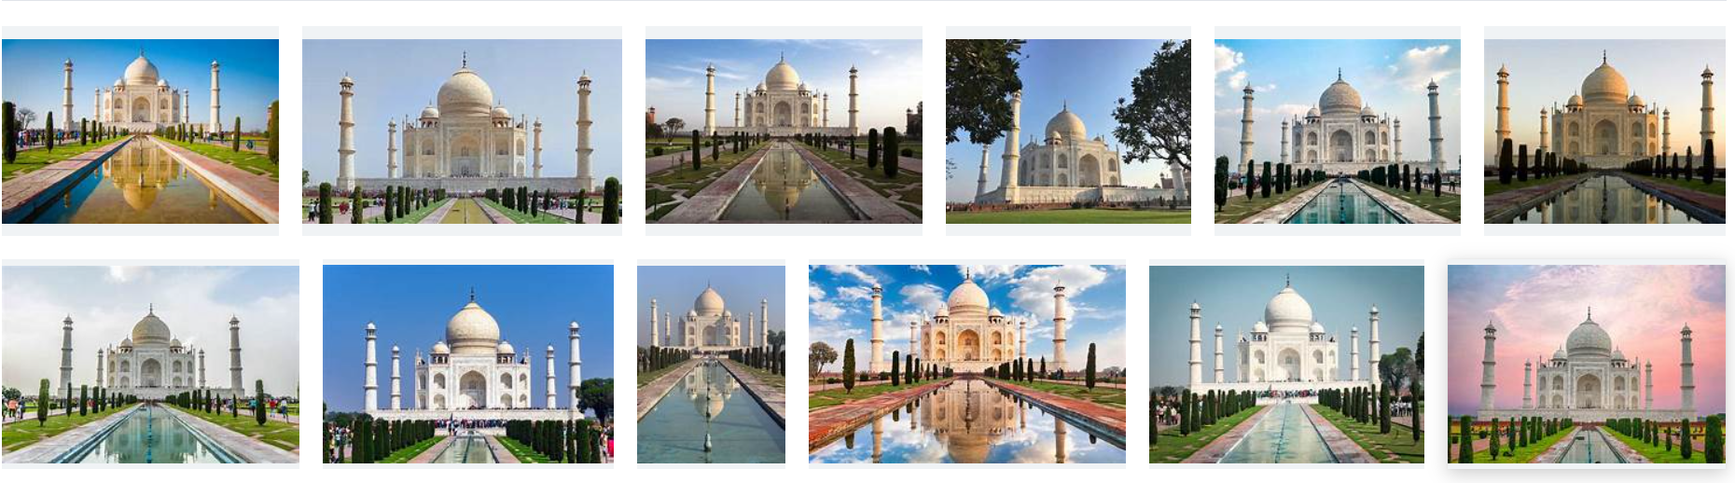

**After click on contact button in navigation bar:**

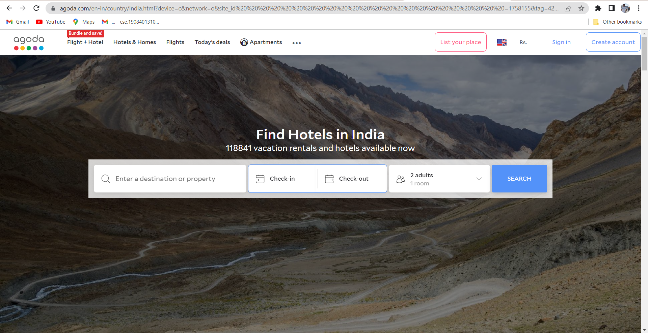

**Output:**

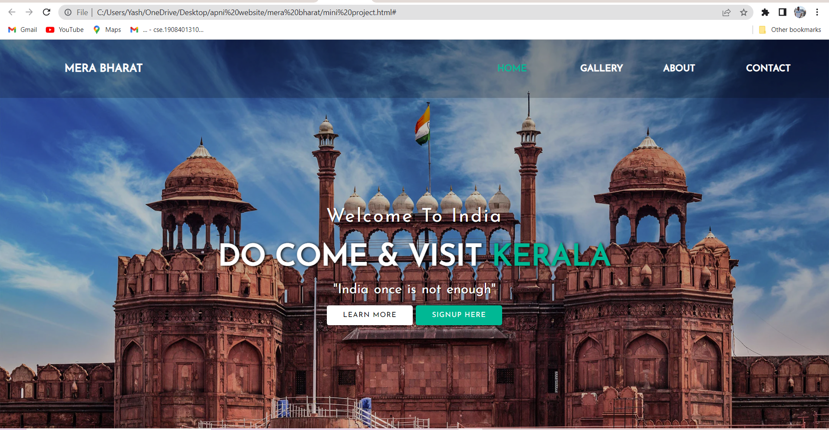

**After click on GALLERY button:**

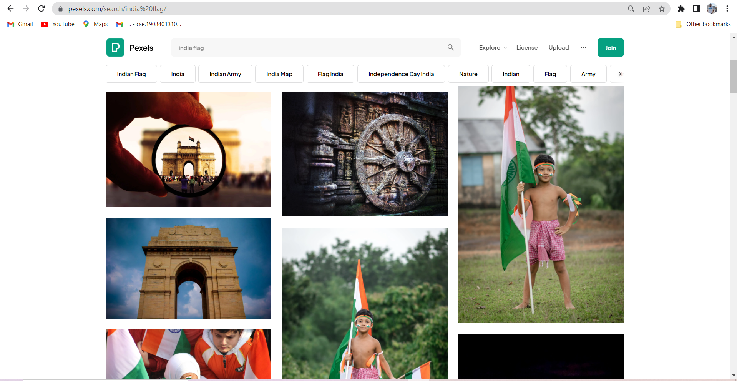

**After click on ABOUT button:**

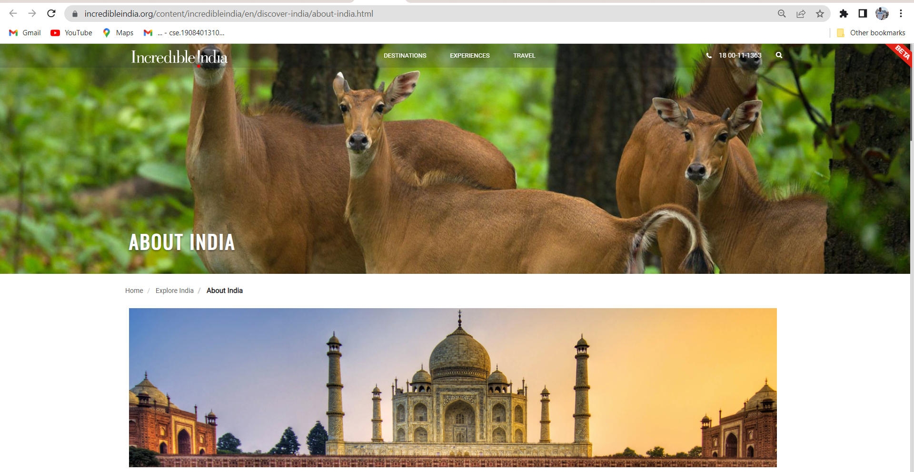

**After click on CONTACT button:**

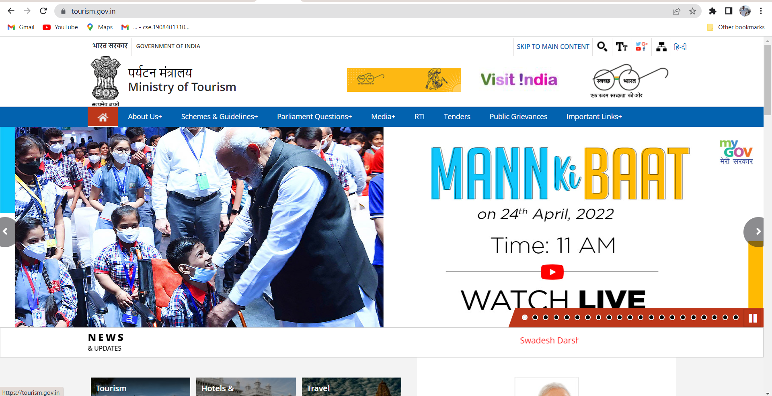

**Output:**

